**Event Reservation Portal**

**Description**

**Objective:**

To work with JavaScript DOM manipulation, event handling, dynamic dropdown generation, and form submission.

**Concept Explanation:**

JavaScript DOM manipulation involves modifying HTML elements and their attributes dynamically on a web page.

Event handling enables executing code in response to user interactions like clicks or keyboard inputs.

Dynamic dropdown generation refers to dynamically populating dropdown menus with options based on certain criteria or data sources.

Form submission involves capturing user input from HTML forms and sending it to a server for processing, often with validation and handling of user interactions.

**Concept Implementation:**

In the script.js file, a function dynamically populates the ticket dropdown based on the selected event from the events dropdown, according to the provided data chart. Another function displays an acknowledgment message in the div tag after submission. It handles scenarios where selections are incomplete or both dropdowns are fully selected

**Problem Description:**

"Event Reservation Portal" is a newly started social service agency organizing a ticket Reservation camp in the city. They need to get the required ticket count to plan and organize the ticket Reservation camp. For this requirement, they require an Events enrollment portal to make people enroll themselves for a ticket Reservation camp by selecting an appropriate event and its tickets. Since there are various events &various types of tickets for each events, they want an optimized web page design using JavaScript.

As a part of this portal, the web page is already created with the required HTML components. Using JavaScript, generate the options of one drop-down based on the selected option of another dropdown.

**Requirement:** Populate the ticket dropdown based on the events dropdown and display the enrollment acknowledgment message on successful registration.

When the user selects the event (from a dropdown) for which he/she would like to get ticket, then the tickets relevant to that events alone must get displayed in the ticket's dropdown. For tickets list and events name, please refer to the Data Chart-1 given below.

**Data Chart-1:**

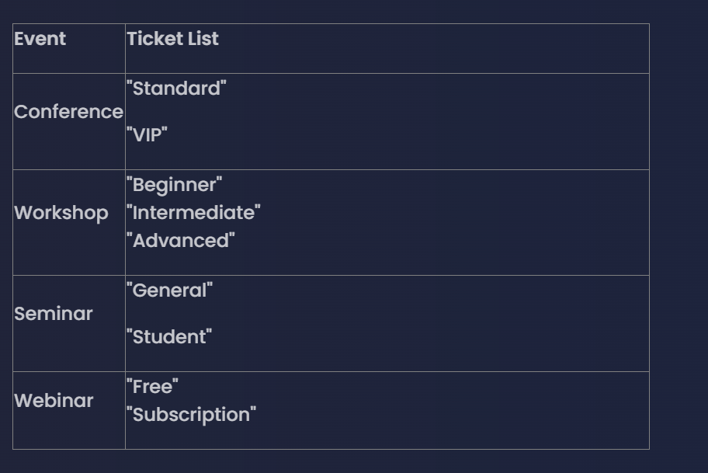

Index.html:-

Script.js  
  
